**Lab 16: (A)Use of Simple Selectors**

**Code:**

 <!DOCTYPE html>

<html>

<head>

<style>

p {

  text-align: center;

  color: red;

}

#para1 {

  text-align: center;

  background-color: blue;

}

.center {

  text-align: center;

  background-color: orange;

}

</style>

</head>

<body>

<!--Element selector-->

<p>EDUNETFOUNDATION</p>

<!--ID selector-->

<p id="para1">TECHSAKSHAM</p>

<!--class selector-->

<p class="center">FULLSTACKWEBDEVELOPMENT</p>

</body>

</html>

**OUTPUT:**

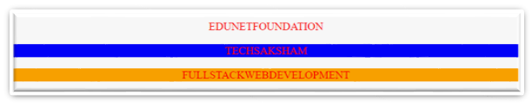

**Lab 16: (B)Use of Color  Properties**

**Code:**

<!Doctype html>

<html>

<head>

<style>

 h1{

    color:blue;

 }

 h2{

    color:#000;

    }

 h3{

    color:rgb(255,100,100);

 }

 h4{

    color:hsl(240,50%,50%);

    }

</style>

</head>

<body>

<h1>CSS COLOR NAME</h1>

<h2>CSS HEX CODE</h2>

<h3>RGB COLOR</h3>

<h4>HSL COLOR</h4>

</body>

</html>

**OUTPUT:**

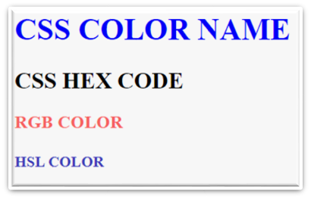

**Lab 16: (C)Use of Background Properties**

**Code:**

<!Doctype html>

<html>

<head>

<style>

 h1{

    background-color:aqua;

 }

 h2{

  background-color: #aeaeae;

 }

 h3{

   background-color:rgba(255,100,100,0.4);

 }

 h4{

    background-color:hsla(240,50%,50%,0.5);

 }

</style>

</head>

<body>

<h1>CSS COLOR NAME</h1>

<h2>CSS HEX CODE</h2>

<h3>RGB COLOR</h3>

<h4>HSL COLOR</h4>

</body>

</html>

**OUTPUT:**

